**Podcast Plus**

**By**

**T Lalith Krishna Teja- 20bce7740 VIT-AP**

**Diwakar Dhawal-20bce11108 VIT-B**

**Archit Agarwal-20bce1773 VIT-C**

**Android Application and Development**

**­**

1. **Introduction**

In recent years, the podcasting industry has witnessed an explosive growth, captivating millions of listeners worldwide with its diverse range of topics, insightful discussions, and captivating storytelling. As the popularity of podcasts continues to soar, the need for innovative and user-friendly platforms to access and enjoy this audio content has become paramount.

This report delves into the development and features of an exceptional Android application designed exclusively for podcast enthusiasts. By combining cutting-edge technology with a seamless user interface, this application aims to revolutionize the way individuals consume and interact with their favorite podcasts.

The project, which is an android application made with the help of Android Studio, aims to provide users a seamless interface to listen to their favorite podcasts at the go.

1. **Literature Survey**

**2.1 Existing Problem:** Existing podcast apps often lack extensive theme customization options, limiting users to predefined themes or fixed color schemes. This restricts personalization and may not cater to individual preferences. Users may desire a more immersive and visually appealing podcast listening experience that aligns with their tastes and moods.

**2.2 Proposed Solution:** The proposed solution for Podcast Plus is to implement dynamic themes inspired by Redux. Redux is a predictable state container widely used in web and mobile application development. By incorporating Redux principles into the app's design, Podcast Plus aims to provide real-time theming updates and a flexible theming architecture.

The method or solution suggested by Podcast Plus involves the following key steps:

1. State Management: Implement a Redux-inspired state management system to handle the app's data and user preferences. Redux utilizes a unidirectional data flow and a central store to manage and update the app's state.
2. Theming Architecture: Design a theming architecture that allows for dynamic theme customization. Users can choose from a variety of theme options, including color schemes, typography, layouts, and visual elements. The chosen themes can be applied and updated in real-time, providing an interactive and personalized experience.
3. Theme Customization Options: Provide users with a range of customization options to personalize their podcast listening experience. These options may include selecting different color palettes, choosing font styles and sizes, adjusting layout preferences, and enabling/disabling specific visual elements.
4. Real-Time Updates: Implement mechanisms to ensure real-time theming updates when users modify their preferences. Whenever a user selects a new theme or modifies customization options, the app should instantly reflect these changes without requiring a restart or manual refresh.

By combining these elements, Podcast Plus aims to create a podcast app for Android that offers a seamless and customizable user experience through dynamic theming, enabling users to create their desired podcast listening environment.

Through this proposed solution, Podcast Plus aims to address the limitations of existing podcast apps, providing users with a more personalized and visually engaging experience while enjoying their favourite podcasts.

1. **Theoretical analysis**
   1. **Block Diagrams**

Use Case Diagram

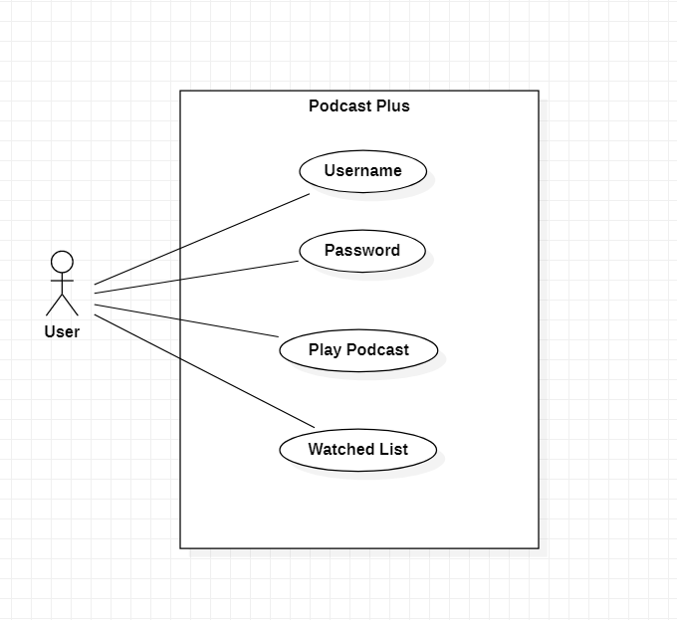

Block Definition Diagram

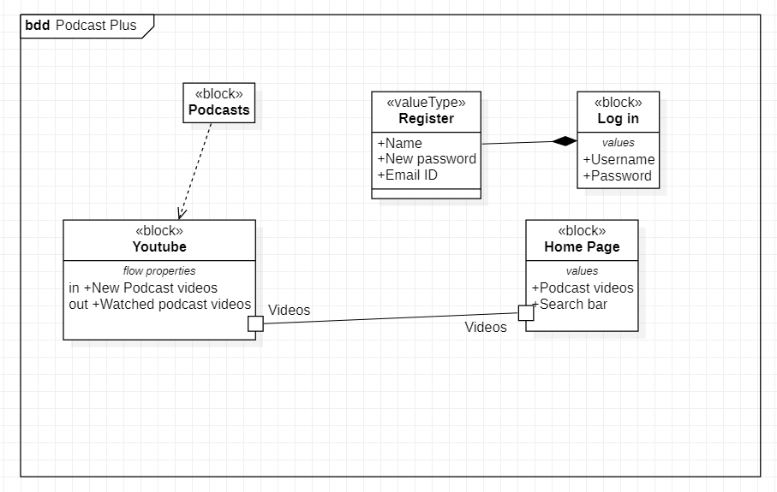

* 1. **Software/Hardware designing**

Software: Kotlin (Jetpack Compose)

Hardware: Android 7.0 and above

1. **Experimental Investigations**

During the development process of Podcast Plus, several experimental investigations were conducted to analyze and refine the solution. These investigations focused on different aspects of the project, including:

1. Research on Existing Podcast Apps: Extensive research was conducted on various existing podcast apps available for Android. The investigation aimed to identify their limitations, particularly concerning theme customization options. This analysis helped gain insights into the existing approaches used in podcast app development and provided a baseline for understanding user expectations and preferences.
2. Study of Redux Principles: As Redux was a key inspiration for the dynamic theming feature in Podcast Plus, a thorough study of Redux principles was undertaken. This investigation involved understanding the core concepts of Redux, such as actions, reducers, and the store. The goal was to analyze how Redux could be adapted and applied effectively in the Android app development context, specifically for implementing dynamic theming capabilities.
3. Design and Implementation of Theming Architecture: An in-depth investigation was carried out to design and implement the theming architecture for Podcast Plus. This investigation involved exploring different approaches and techniques for managing themes, such as utilizing CSS-like stylesheets or leveraging Android's theming system. The investigation also considered the best practices for organizing and structuring theme-related code, ensuring modularity and reusability.
4. User Feedback and Usability Testing: To validate and refine the solution, user feedback and usability testing were conducted. A group of potential users was selected to test the app's dynamic theming capabilities. Their feedback and observations were collected through surveys, interviews, and user testing sessions. The investigation aimed to understand how users interacted with the theme customization options, the usability of the interface, and any potential issues or areas for improvement.
5. Performance Analysis: Performance analysis was conducted to evaluate the impact of the dynamic theming feature on the app's performance. This investigation involved measuring metrics such as CPU usage, memory consumption, and rendering times when applying and switching between different themes. The goal was to ensure that the dynamic theming feature was implemented efficiently and did not negatively affect the overall app performance.

Through these experimental investigations, valuable insights were gained, allowing for iterative improvements and refinements of the solution. The analysis helped in understanding user expectations, optimizing performance, and ensuring a seamless and satisfying user experience with the dynamic theming feature in Podcast Plus.

1. **Flowchart**

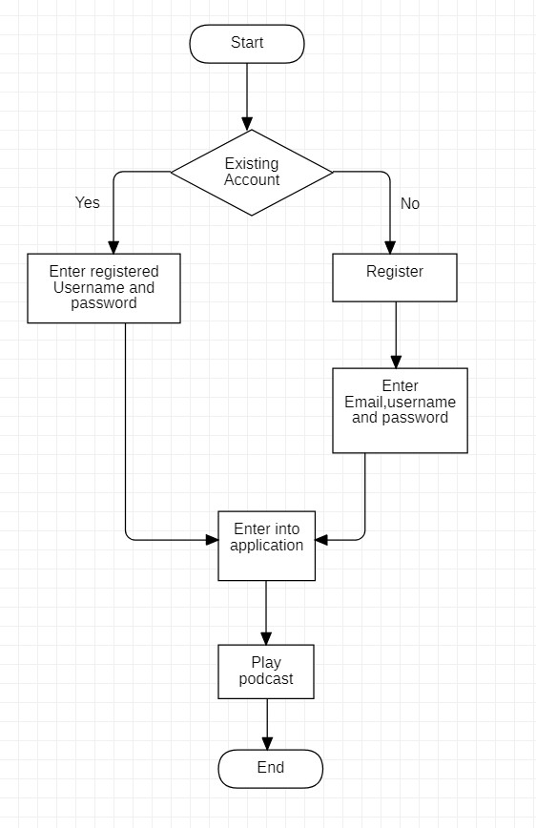

1. **Result**

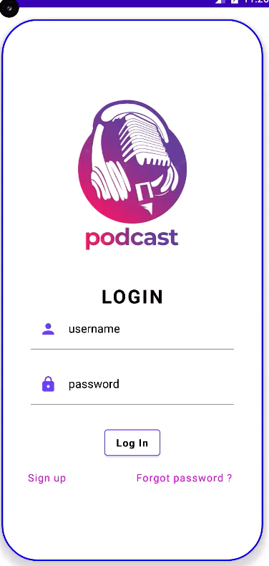 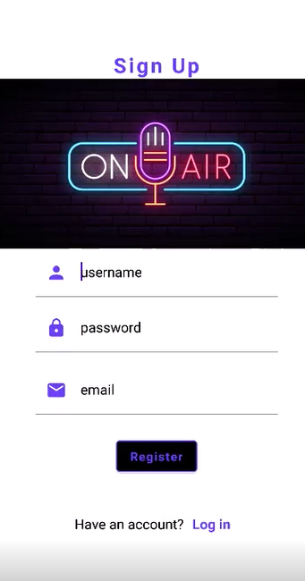

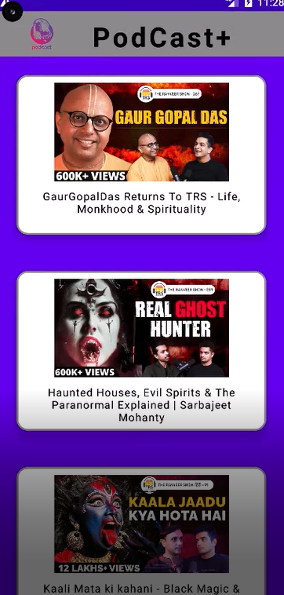 

1. **Advantages and Disadvantages**

Advantages of the Proposed Solution:

1. Enhanced User Experience: The dynamic theming feature in Podcast Plus offers users an enhanced podcast listening experience by allowing them to personalize the visual appearance of the app. Users can choose from a variety of themes, color schemes, and visual elements, creating a customized and immersive environment that aligns with their preferences.
2. Real-time Theming Updates: With the integration of Redux principles, Podcast Plus provides real-time theming updates. When users select a new theme or modify customization options, the app instantly reflects these changes without requiring a restart or manual refresh. This ensures a seamless and interactive theming experience.
3. Flexibility and Customization: The proposed solution enables users to have greater flexibility and control over the visual appearance of the app. They can customize various aspects such as color palettes, typography, layout preferences, and other visual elements. This level of customization empowers users to create a podcast listening environment that suits their individual taste and mood.
4. Personalization and Branding: Podcast Plus allows podcast creators to offer a branded and visually appealing listening environment to their audience. By providing customization options, creators can align the app's visual identity with their brand, fostering a cohesive and immersive experience for their listeners.

Disadvantages of the Proposed Solution:

1. Increased Complexity: The integration of dynamic theming features inspired by Redux may introduce additional complexity to the development and maintenance of the app. Managing state changes, maintaining consistency across themes, and ensuring smooth transitions between different visual elements require careful implementation and testing.
2. Development and Maintenance Effort: Supporting a wide range of themes and customization options may require additional development effort and ongoing maintenance. The app needs to handle different theme variations, compatibility across different Android versions and devices, and potential conflicts with other app functionalities.
3. User Learning Curve: The availability of extensive customization options and the complexity of managing themes may introduce a learning curve for users. Some users may find it challenging to navigate and understand the customization features, potentially affecting their overall experience with the app.
4. Performance Considerations: The dynamic theming feature could potentially impact the app's performance, especially on devices with limited resources. Implementing efficient algorithms and optimizing resource usage are crucial to ensure smooth and responsive theming changes without compromising the overall app performance.

It is important to note that the disadvantages can be mitigated through careful design, implementation, and thorough testing to ensure that the benefits outweigh any potential drawbacks.

1. **Applications**

The proposed solution of Podcast Plus with dynamic themes for Android can be applied in various areas, including:

1. Podcast Listening Platforms: The primary application of Podcast Plus is in podcast listening platforms. This solution can be integrated into existing podcast apps or used to develop new apps that offer enhanced theming capabilities. By providing users with personalized and visually appealing experiences, podcast listening platforms can attract and retain a larger user base.
2. Content Creators and Podcasters: Podcast Plus can benefit content creators and podcasters by offering them a platform to engage with their audience in a visually immersive way. By aligning the app's themes with their brand and content, creators can enhance their branding and create a cohesive experience for their listeners.
3. Media and Entertainment Companies: Media and entertainment companies can utilize Podcast Plus to develop their own branded podcast app. This solution allows them to create a unique and visually captivating experience for their audience, promoting their content and strengthening their brand identity.
4. Audio Content Discovery Platforms: Platforms that focus on audio content discovery, such as podcast directories or recommendation engines, can incorporate Podcast Plus to provide a more engaging user experience. By enabling users to customize the app's themes and aesthetics, these platforms can enhance user satisfaction and encourage longer engagement with the content.
5. Education and Learning Platforms: Podcast Plus can be applied in education and learning platforms that incorporate audio-based educational content. By offering dynamic theming options, these platforms can create visually stimulating environments that enhance the learning experience and cater to the preferences of individual learners.
6. Social Podcasting Platforms: Social podcasting platforms, where users can engage in discussions, share recommendations, and connect with other podcast enthusiasts, can benefit from Podcast Plus. The dynamic theming feature can create a visually cohesive and engaging environment for users to interact and build a community around their shared interests.
7. Personal Entertainment and Relaxation: Individual users seeking a personalized and visually appealing podcast listening experience can directly benefit from Podcast Plus. By allowing them to customize the app's themes, users can create a soothing, vibrant, or immersive environment that aligns with their mood and preferences, enhancing their personal entertainment and relaxation.

The application of Podcast Plus is not limited to these areas and can be extended to any domain that involves audio content consumption and user engagement. The solution's flexibility and customization options make it adaptable to various contexts and industries, offering a tailored and visually captivating experience to users.

1. **Future Scope**

* Being able to create personal playlists: Users will be able to add favorite podcast episodes into a personal playlist of their own. This can also be shared with other people through links.
* Subscription to different podcasts: Just like YouTube, users will be able to subscribe to different podcasts. Podcast hosts can decide if they want to have a premium subscription on top of a free version, where they can offer more content to their paid subscribers.
* Premium version with better sound quality and no advertisements: Premium version of the application can be launched with better sound quality, no advertisements on the application and one free 1 month paid subscription every month of purchase towards a podcast.

1. **Conclusion**

The application, Podcast Plus, is still in the beginning phases of development, but its potential is endless. With every new update, we envision to bring about more features, while listening to feedback from our users. The podcast market is a booming business and Podcast Plus can and will be the application to change it completely, by increasing user interactions and QoL improvements.

1. **Bibliography**

* <https://mlpearson4.github.io/VastCast/pictures/Design.pdf>: Used to reference report making and diagrams.
* <https://androidexample365.com/android-podcast-app-made-with-jetpack-compose-and-exoplayer-2/>: Reference/helped in building code.
* <https://emmanuelevilla.com/my-sample-android-app-with-compose-and-redux-using-the-nasa-apis/>: Reference for application with redux and jetpack compose in an application.

1. **Appendix**

* <https://github.com/Dark-Coders995/Podcast_Plus> : Code of our App